SQL Queries

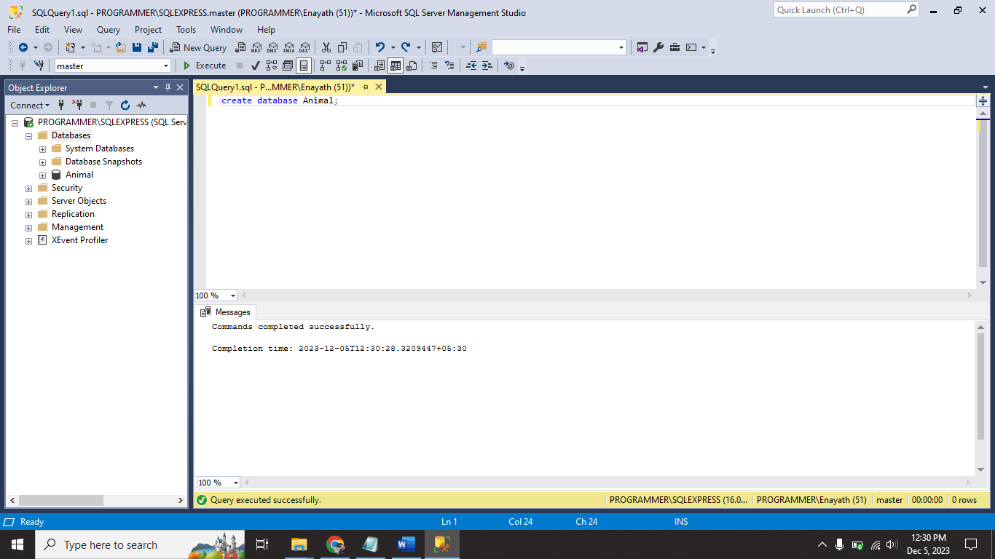

Data base successfully created using **CREATE** command.

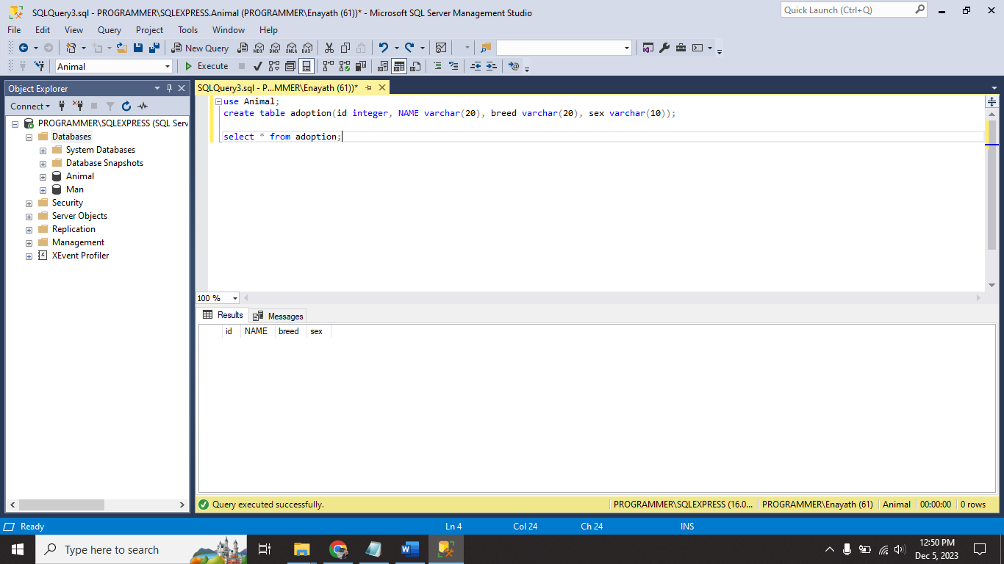

Table successfully created in Animal database using **CREATE** command

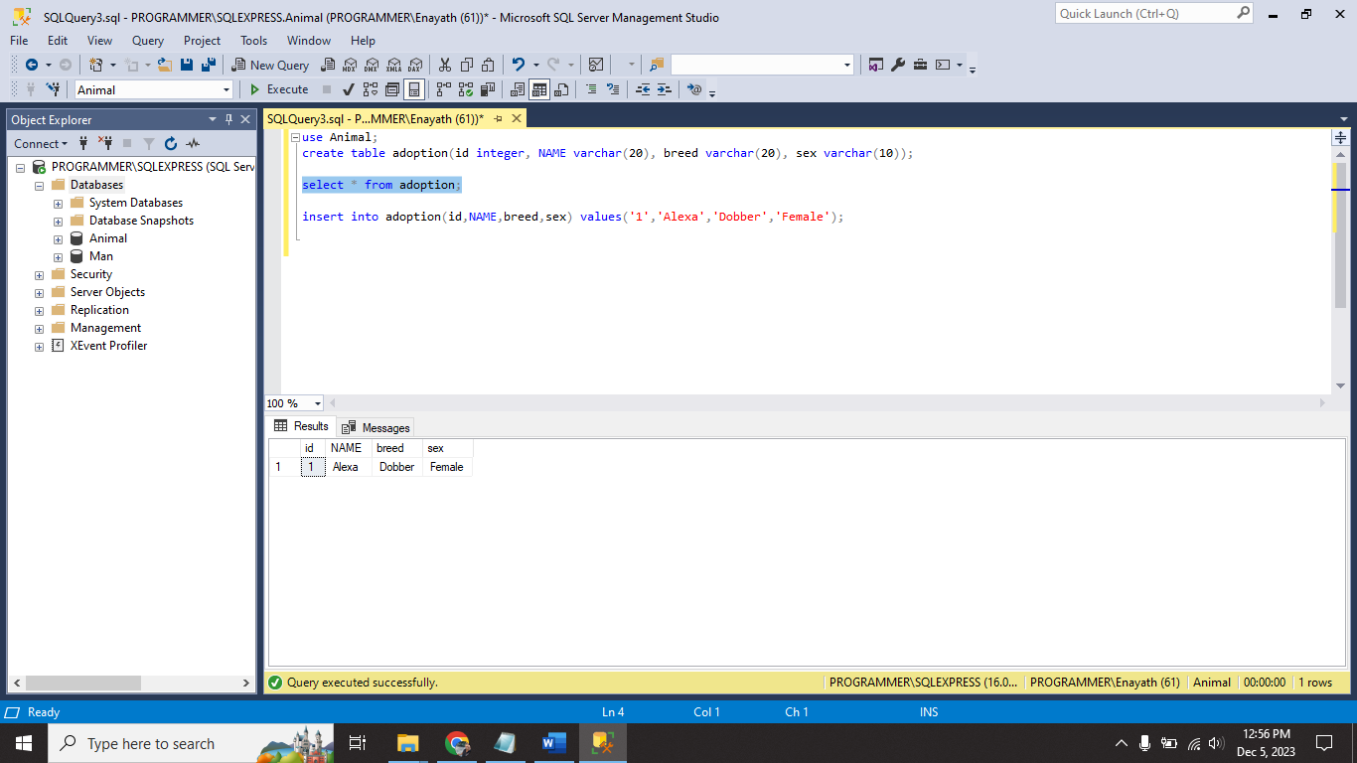

Successfully inserted row in table using **INSERT**

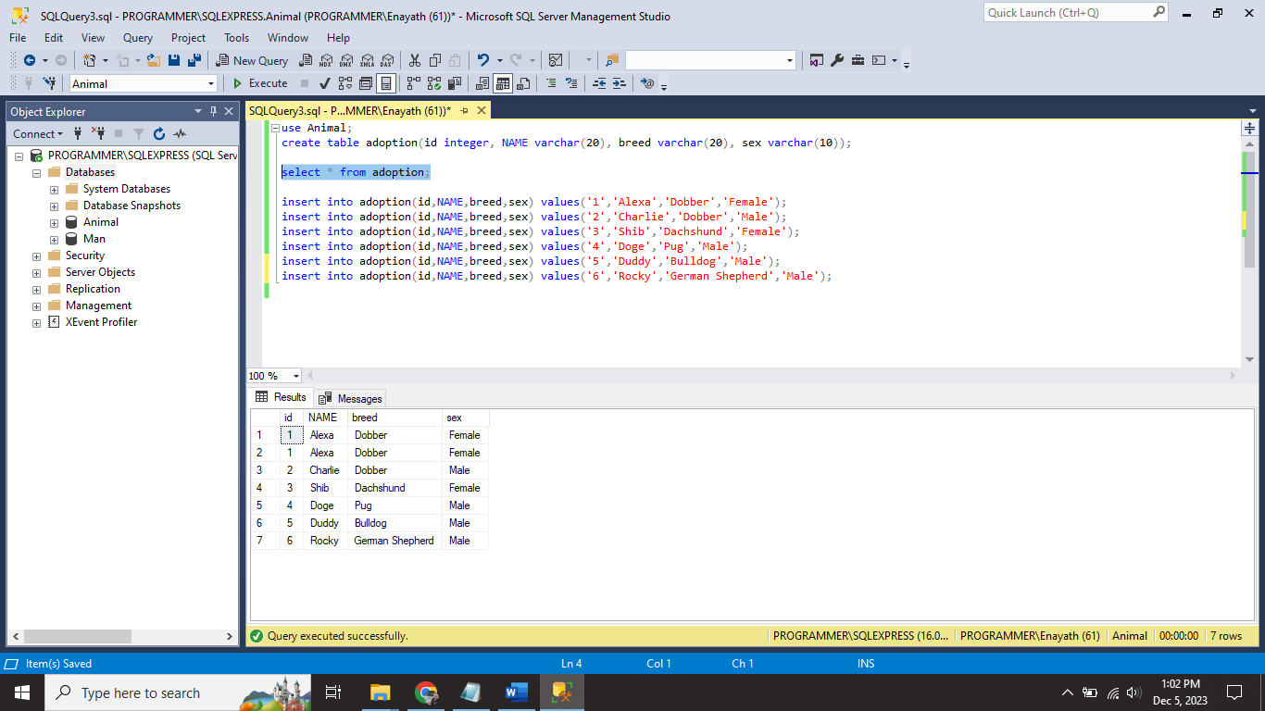

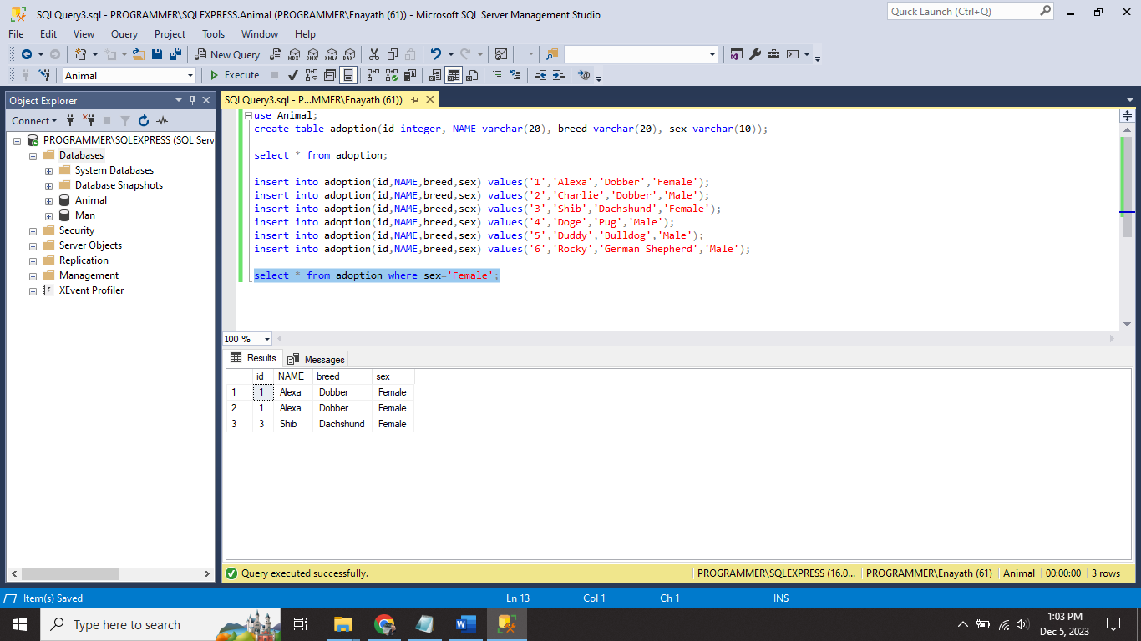

Successfully filter the table with the help of **WHERE** command.

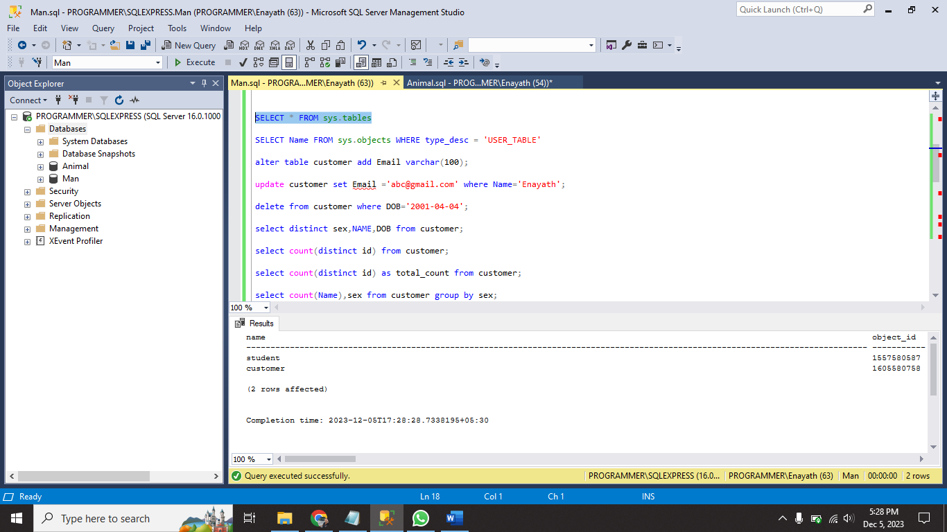

Displaying available tables in database using SELECT * FROM sys.tables;

SELECT Name FROM sys.objects WHERE type_desc = 'USER_TABLE';

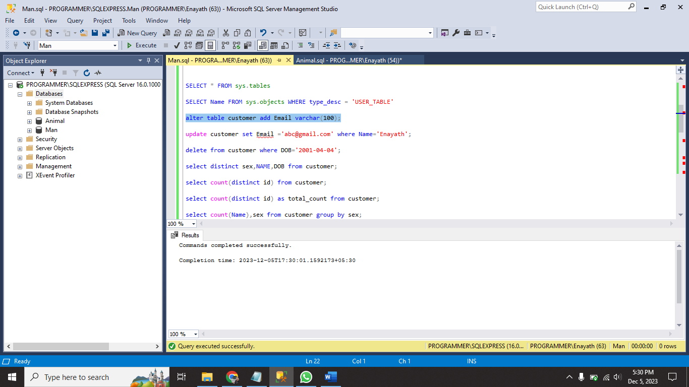

Add the Email column with help of **ALTER** command.

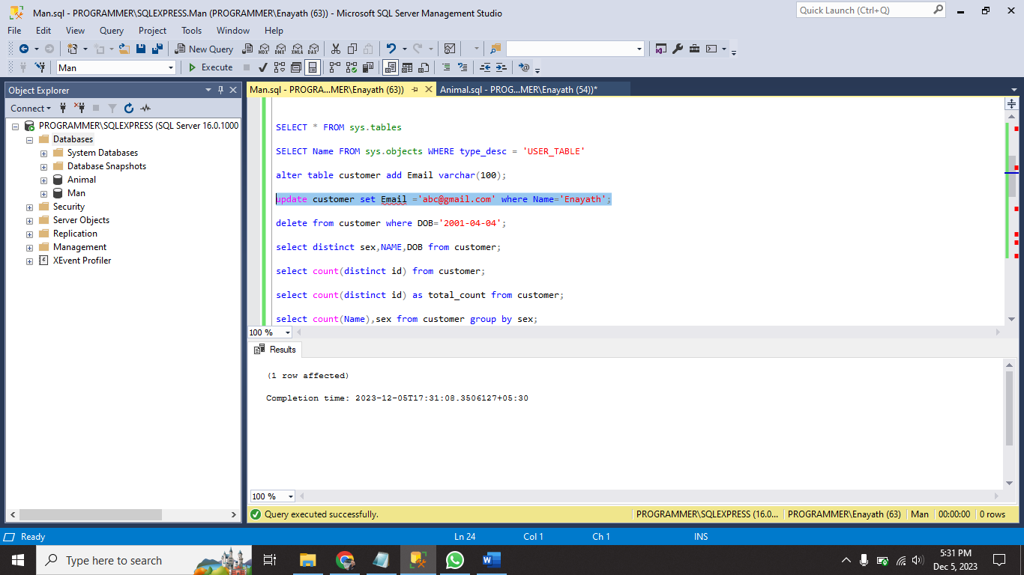

Using **UPDATE** I updated mail id in customer table

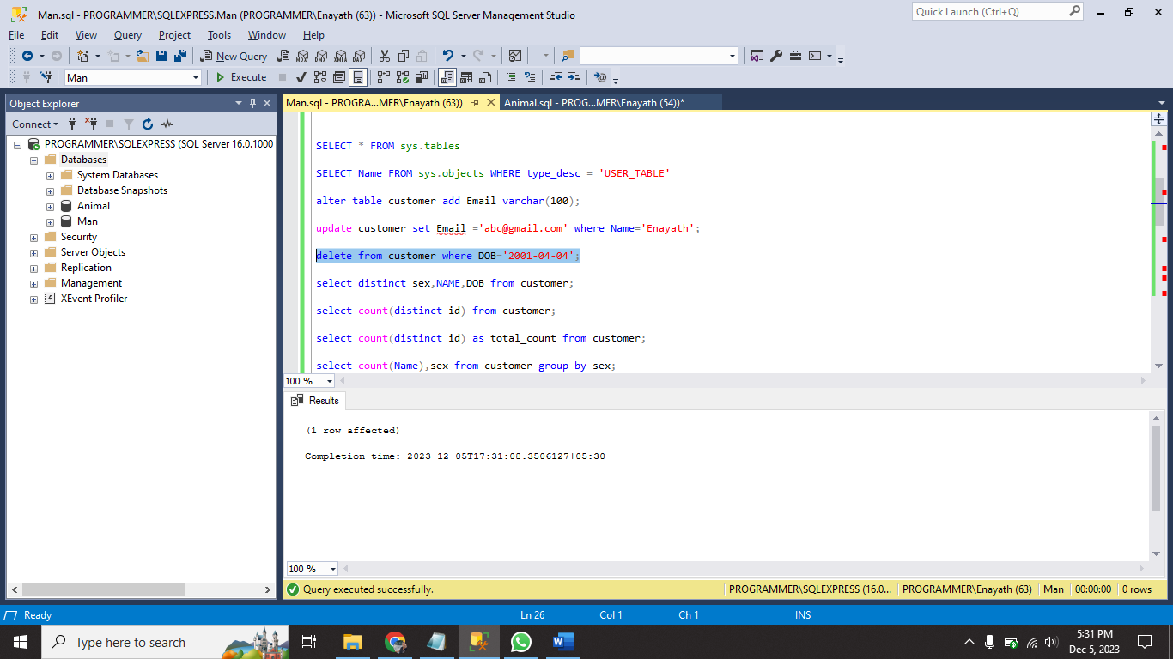

Delete a row using **DELETE** command.

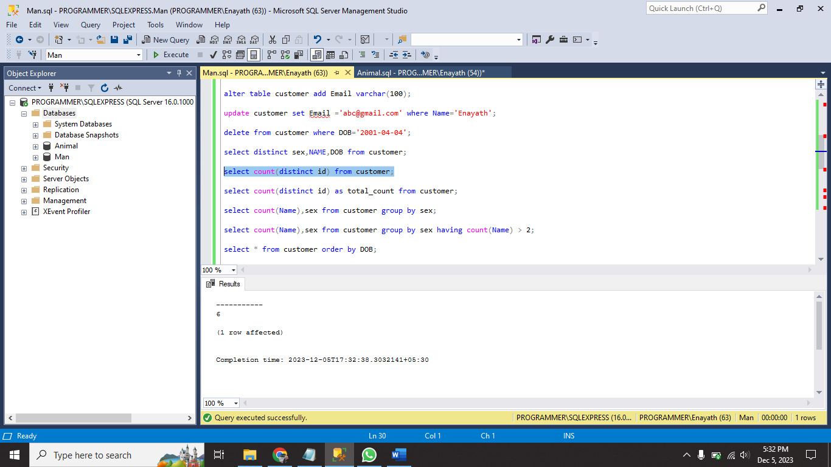

Using **COUNT** for display how many id’s present in customer table.

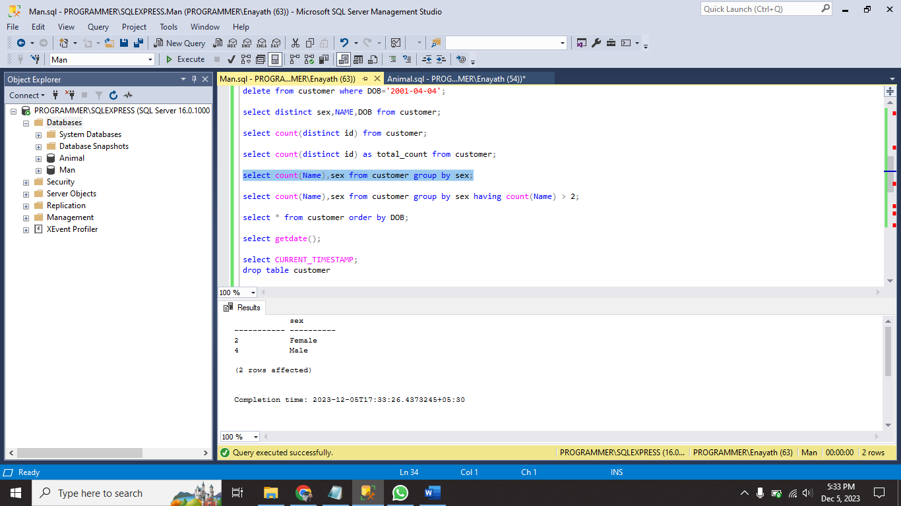

Using **GROUP BY** display table groupby column name.

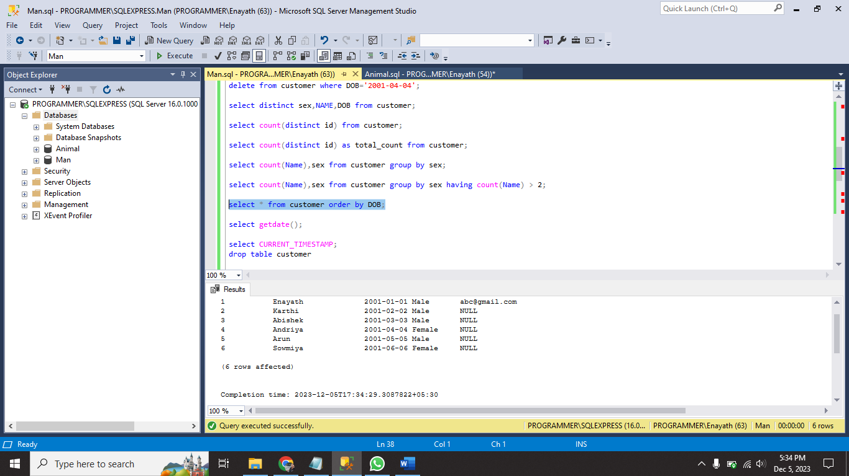

Using **ORDER BY** I sort the table.

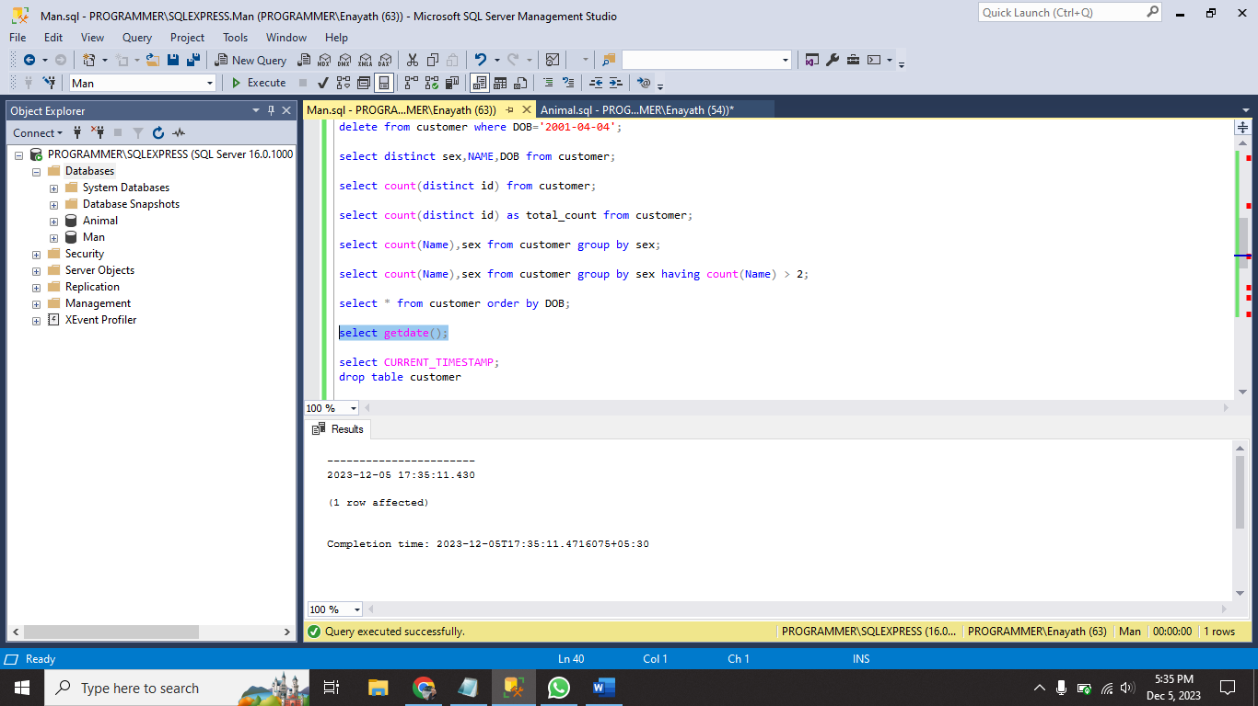

Using getdate() and CURRENT_TIMESTAMP we will print current system date and time.

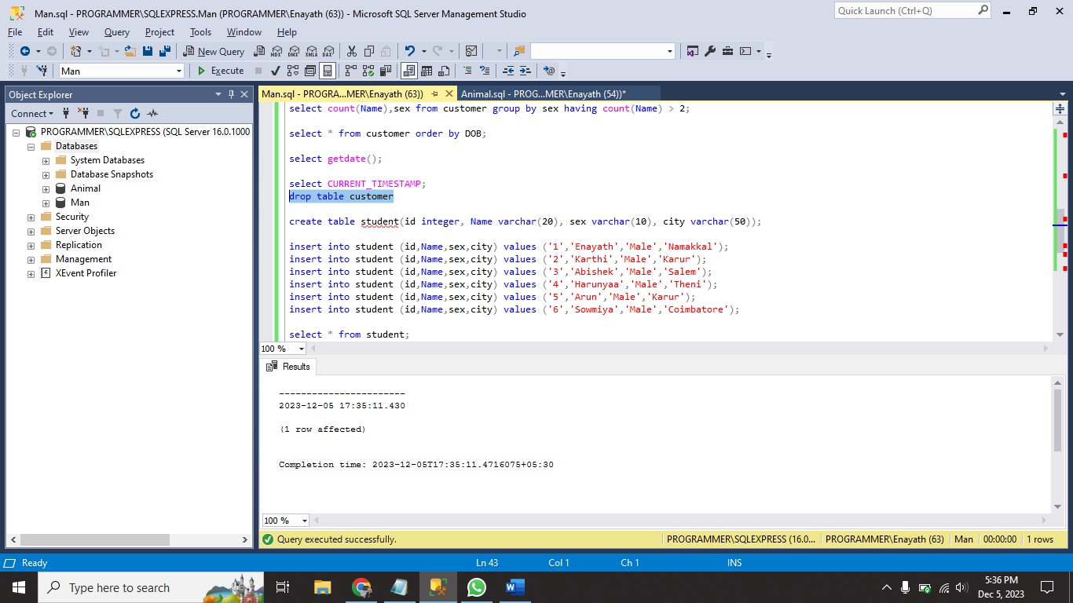

Delete the customer table with the help of DROP command.

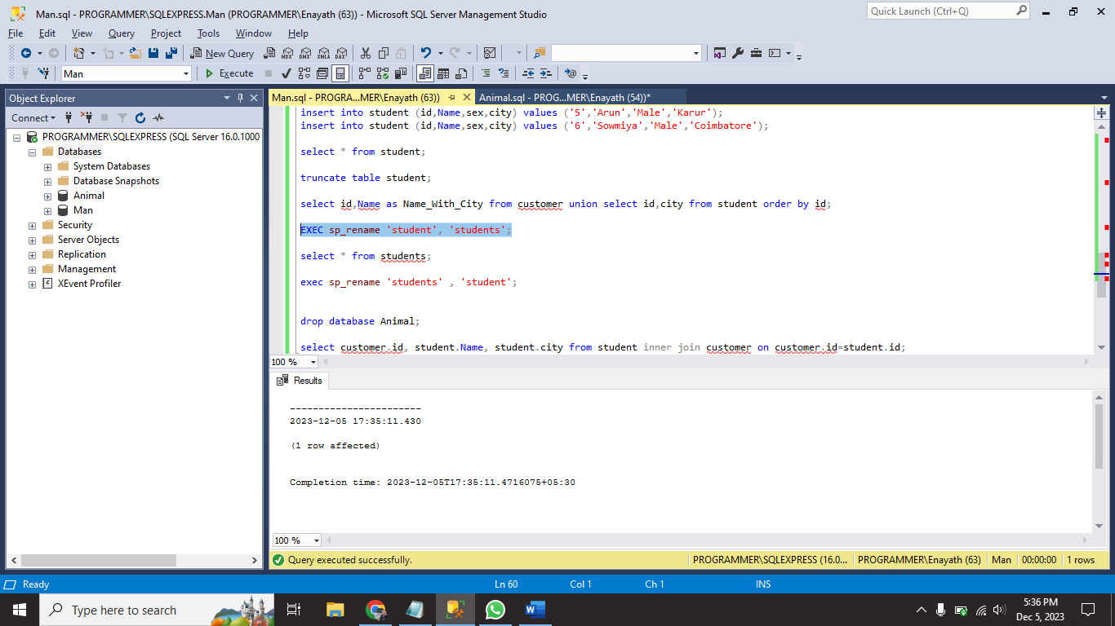

Rename the Table using **EXC sp_rename ‘old table name’ , ‘new table name’;**

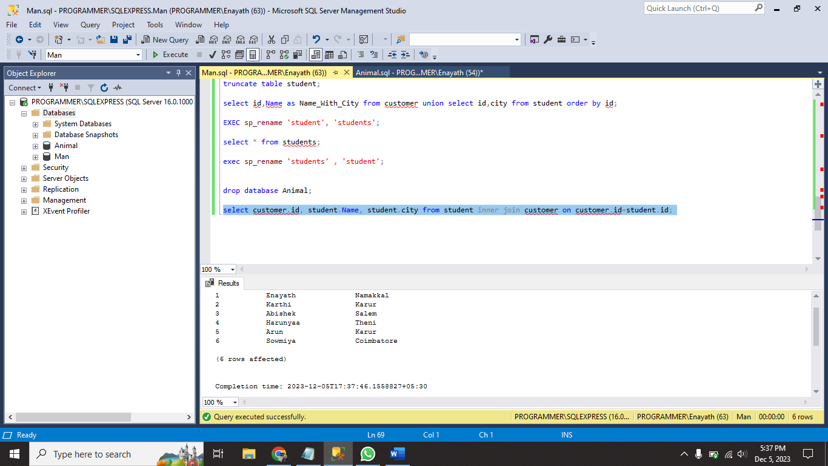

Using **INNER JOIN** I joined two different tables in same databse.